**Risk Project Code Convention**

This document serves as the complete definition of Risk Project coding standards for source code in the Java™ Programming Language.

This standards will cover three basic rules, layout, naming and comment, to increase code readability/understandability.

1. Layout

1.1 Block Indentation: +4 spaces

Each time a new block or block-like construct is opened, the indent increases by two spaces. When the block ends, the indent returns to the previous indent level. The indent level applies to both code and comments throughout the block.

1. Naming

2.1 File Name:

File names use ModelClass.java

2.2 Package names

Package names are all lowercase, with consecutive words simply concatenated together (no underscores). For example, modelpackage, not Model or MODEL.

2.3 Class names

Class names are written in ModelClass.

2.4 Method names

Method names are written in getRiskData(localData){ }

2.5 Constants names

Constant names use CONSTENT_DATA

2.6 Local variable

Local variable names use localData

2.7 Data Member

Data Member names use dataMember

2.8 Global variable:

Global variable names use RISKdata

1. Comment

3.1 Javadoc Formatting

For class: basic class description

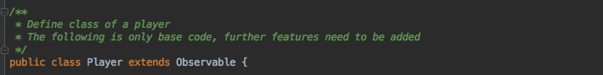

For method: method, parameters and return value description

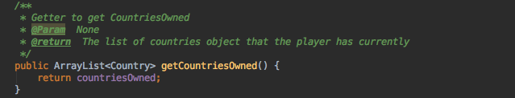

3.2 Other Comment Format

3.2.1 When the meaning of the code by itself is not completely obvious and unambiguous. Use “ // explanation” format.

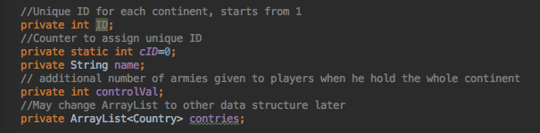

3.2.2 “Comment out” code. Use // at the beginning of each line (hotkey: commend + /)

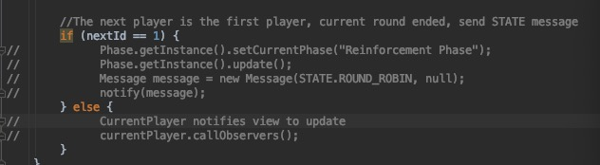

3.3.3 Comments in a long method. Block each small functional code, and put one or more line comments before that block, using “// ”.

